NEW FORMS
SPECIFICATION

References 4
List of Fields 4
Access Right Management 6
1. Basic Form Visualization, No Toolbar 7
Views 7
Space Form 7
Project Form 8
Collection Form 9
Object Form 9
DataSet Form 10
Model 10
Client-Server Communication 10
Form Rendering 10
Requirements 11
Functional Requirements 11
Non Functional Requirements 12
Adaptor to a single model, we can call this AdaptorForm 12
But somewhere we need to build this adaptor DTO from the actual Entity, EntityKind and EntityType 13
2. Basic Form Edit, Initial Toolbar 15
Views 15
Model 15
Requirements 15
Functional Requirements 15
Non Functional Requirements 15
3. Basic Toolbar Actions 16
Views 16
Model 16
Requirements 16
Functional Requirements 16
4. Form Creations 17
Views 17
Model 18
Requirements 18
Functional Requirements 18
5. Form Visualization and Edit – Part 2 (Muti-Valued Fields) 19
Views 19
Requirements 20
Functional Requirements 20
6. Form Visualization and Edit – Part 3 (Spreadsheet) 20
Views 20
Model 20
Requirements 20
Functional Requirements 20
7. Advanced Toolbar Actions 21
Views 21
Model 21
Requirements 21
Functional Requirements 21
8. Form Visualization and Edit – Part 4 (Parents/Child widget) 22
Views 22
Model 23
Requirements 23
9. Plugin System (To be used by ELN to integrate Storage and other) 23
View 24
Model 24
Requirements 24

References

List of Fields
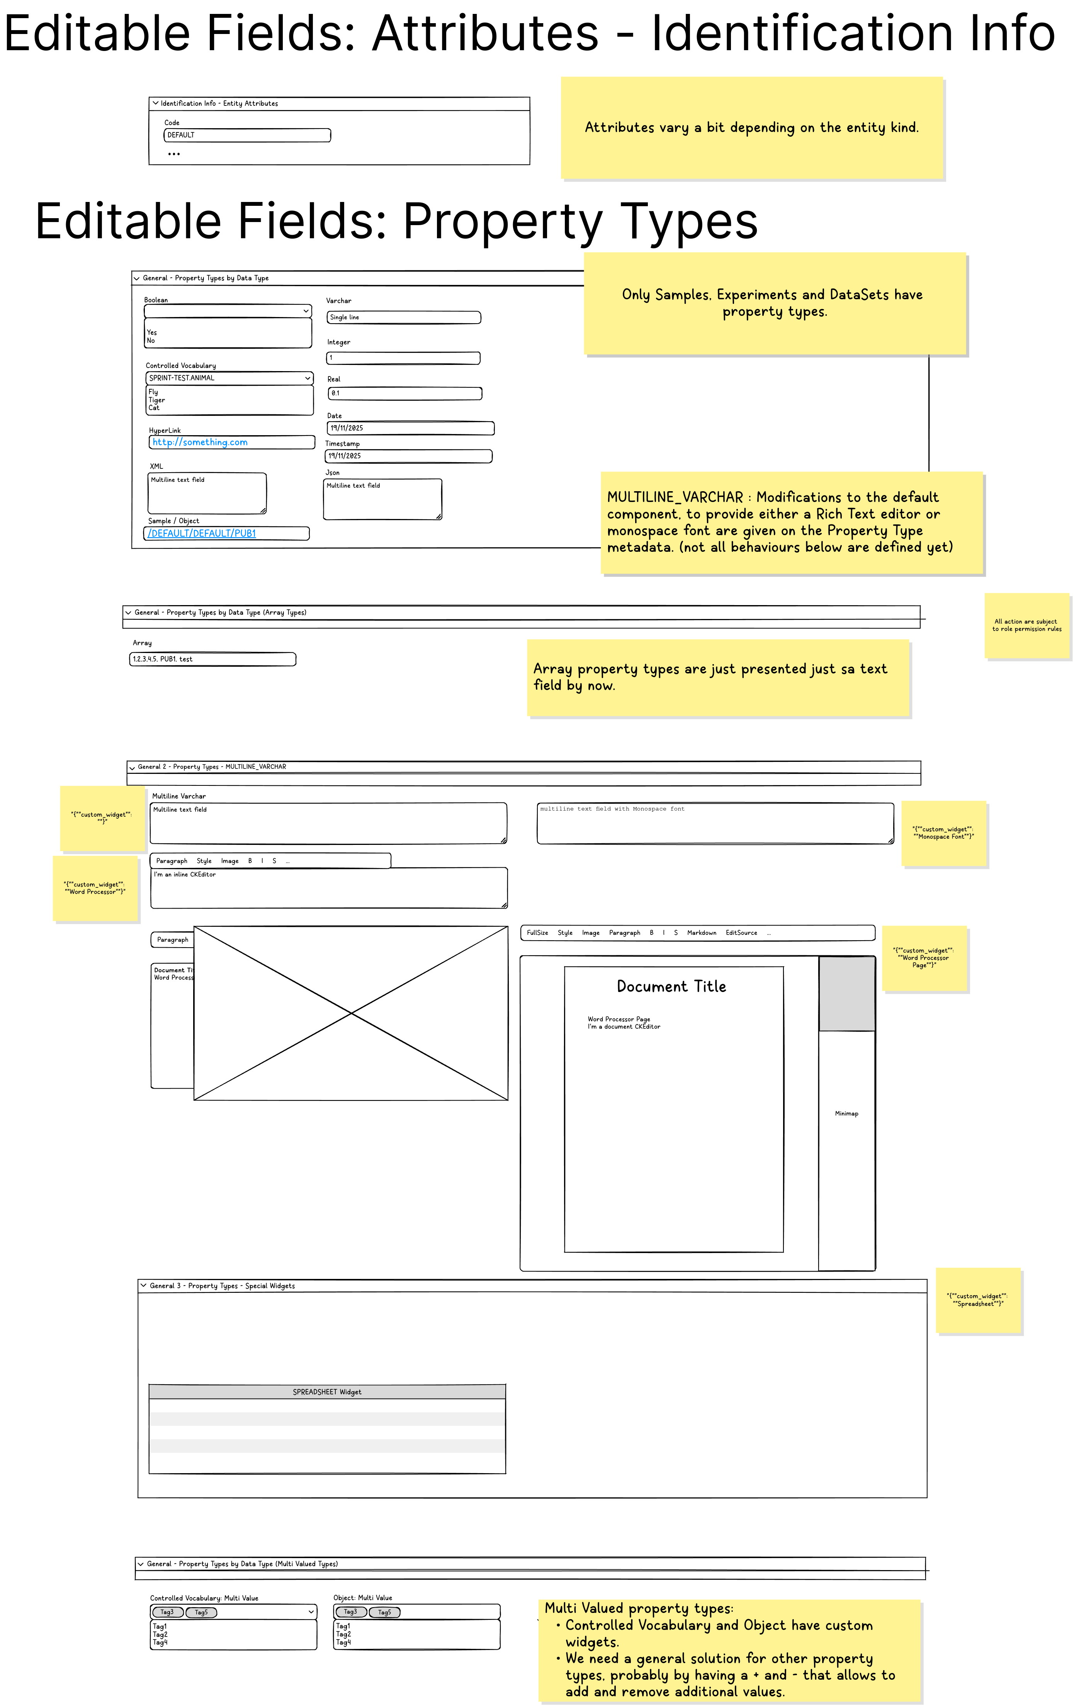

Access Right Management
- Ideally we are not showing buttons for actions that a particular user cannot do.
- To know if a particular user can create/update/delete a particular ID the function getRights should be used. This function should be called as part of the data to be fetch to render the form.
public Map<IObjectId, Rights> getRights(String sessionToken, List<? extends IObjectId> ids, RightsFetchOptions fetchOptions);
- Configuration of Roles on the system can be modified so there is no way of knowing the rights of a particular user given his role, calling this function is MANDATORY.

1. Basic Form Visualization, No Toolbar

Views

Space Form

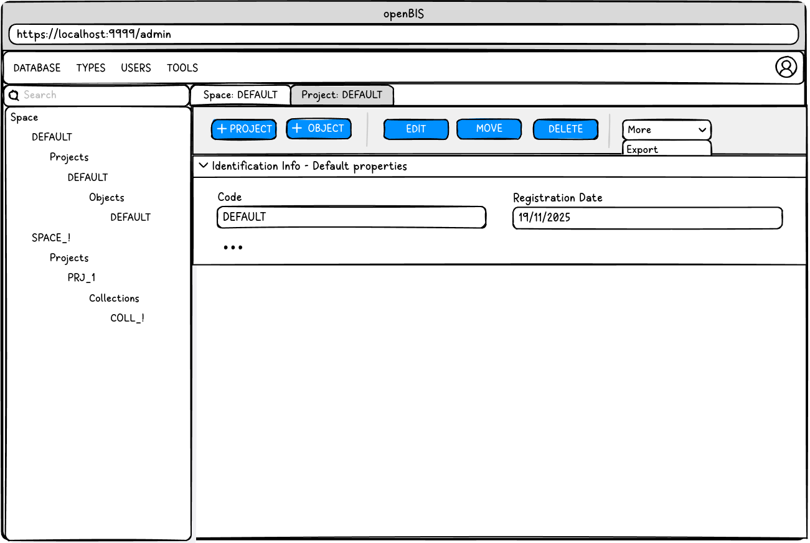

Project Form
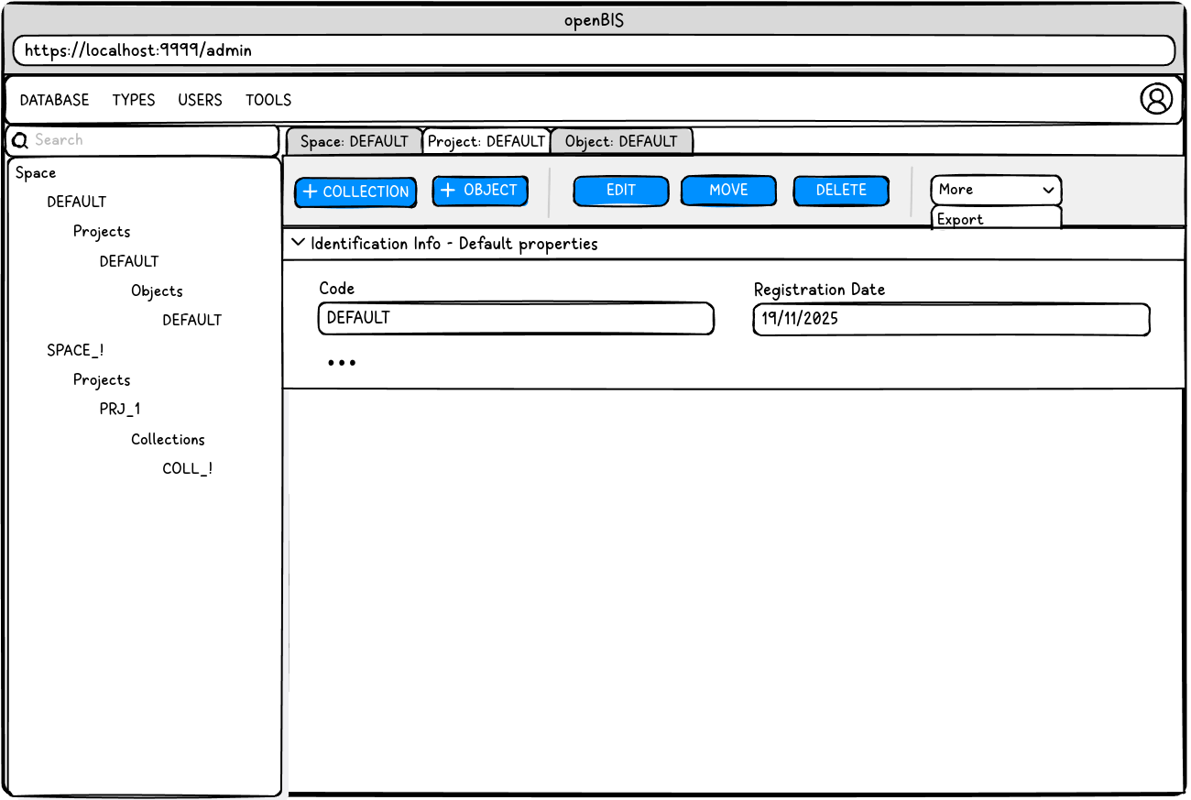

Collection Form
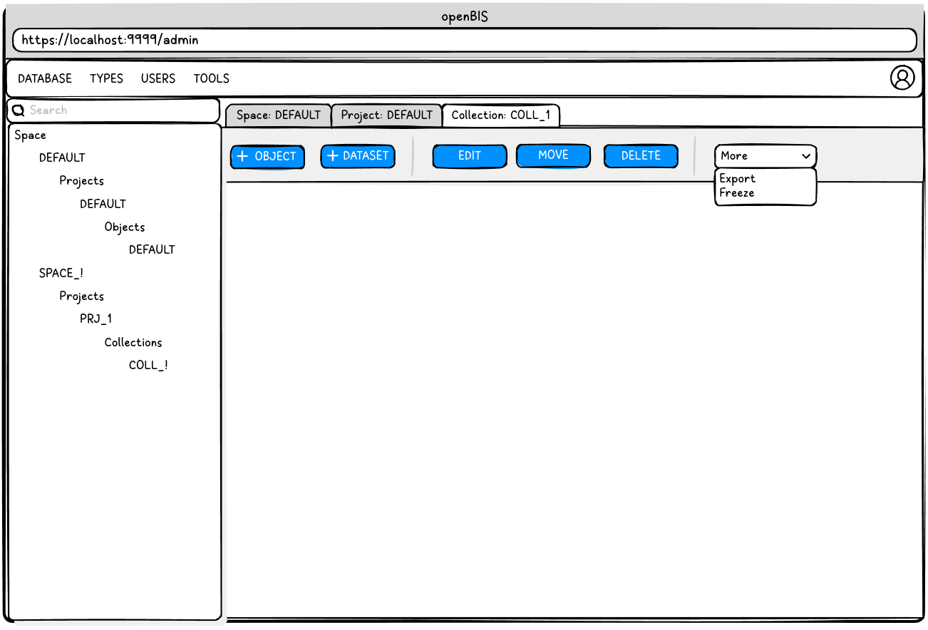

Object Form

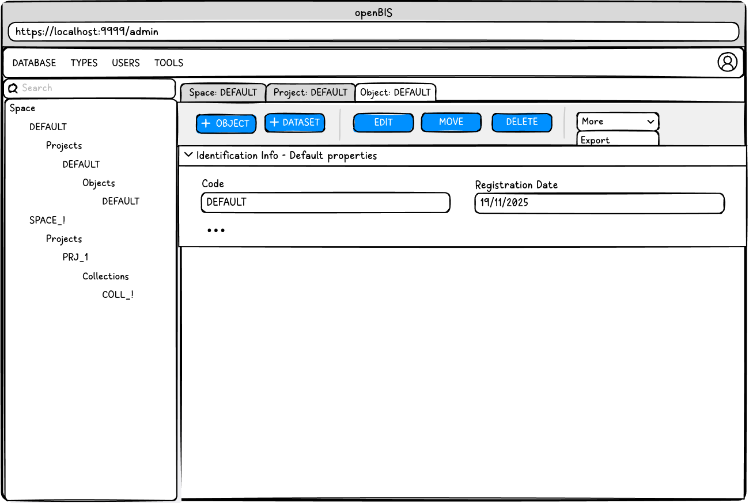

DataSet Form

Model

Client-Server Communication
At all points of these specification we are using the existing openBIS model.
There is no need to create or extend the model in any way.
ch.ethz.sis.openbis.generic.asapi.v3.dto.space.Space
ch.ethz.sis.openbis.generic.asapi.v3.dto.project.Project
ch.ethz.sis.openbis.generic.asapi.v3.dto.sample.Sample
ch.ethz.sis.openbis.generic.asapi.v3.dto.experiment.Experiment
ch.ethz.sis.openbis.generic.asapi.v3.dto.dataset.DataSet

Form Rendering

Take into account special behaviors for the text fields:
Data Type: MULTILINE_VARCHAR
Metadata: { “custom_widget” : “Word Processor” }
Metadata: { “custom_widget” : “Word Processor Page” }
Metadata: { “custom_widget” : “Monospace Font” }

Requirements

Functional Requirements
- Render for all 5 forms the Identification Information Section containing the attributes of the entities.
Space
Code
Description
Project
Code
Description
Experiment
Code
Project
Identifier
Experiment Type
Sample
Code
Space
Project
Experiment
Identifier
Sample Type
DataSet
Code
Experiment
Sample
DataSet Type

For all 5 Forms
Registrator
Registration Date
Modifier
Modification Date
For forms with properties
Property Type Assigned defined section
Property Type defined Fields (Basic, Arrays, CKEditor)

Non Functional Requirements
- All 5 forms use only the V3 API
- All 5 forms to fetch the initial information and to do updates SHOULD o it transactionally in a single fetch call, using batch operations.
- All 5 forms use a common model to render the form, to simplify extending them and maintaining them.

Adaptor to a single model, we can call this AdaptorForm
The next model is work in progress, don't take it as gospel.
1 DTO
A Form represents an Entity to be edited or manipulated in some way.
enum FormMode { view, new, edit }
enum DataType { openbis-data-types + word-processor + spreadsheet }
Form
- entityId <- permId
- title
- List<Field>
- meta
FormField
- formFieldTypeId <- PropertyType
- Value
- DataType
- meta

But somewhere we need to build this adaptor DTO from the actual Entity, EntityKind and EntityType
We will encapsulate entity kind and type specific logic into the controller of the form.
Every rendered Field should be updating its FormField model as the user fill it.
EntityForm(Form form, FormMode mode, FormController controller)
private Form form;
private FormMode mode;
private FormController controller;
private List<Button> toolbar;
load() {
This can happen outside of the main thread to load anything necessary
controller.load(form, mode);
}
render() {
}
save() {
controller.save(form, mode);
}
edit() {
controller.edit(form, mode);
}
delete() {
controller.delete(form);
// Leave not implemented
}
move() {
controller.move(form);
// Leave not implemented
}
checkPermissions() {
}

2. Basic Form Edit, Initial Toolbar

Views
Same as previous section

Model
Same as previous section

Requirements

Functional Requirements
Edit/Save
- Editable attributes
- Properties
Autosave feature
Conflict resolution

Non Functional Requirements
- We should have an extensible toolbar where the form attaches its buttons and allow to attach others.
- Only actions that can be done by the user should attach buttons. For that you need to check the user rights. There is a call on the V3 API for this, is used on the ELN.
- Client side, auto-save, maybe once a minute, maybe the user can enable/disable the feature with a sidebar at the top of the form.
- Conflict resolution, avoid editing entities of a different version. Provide feed back to the user if properties collide so he can edit it. If properties don't collide it can be resolved silently.

3. Basic Toolbar Actions

Views
Same as previous section
Object Move
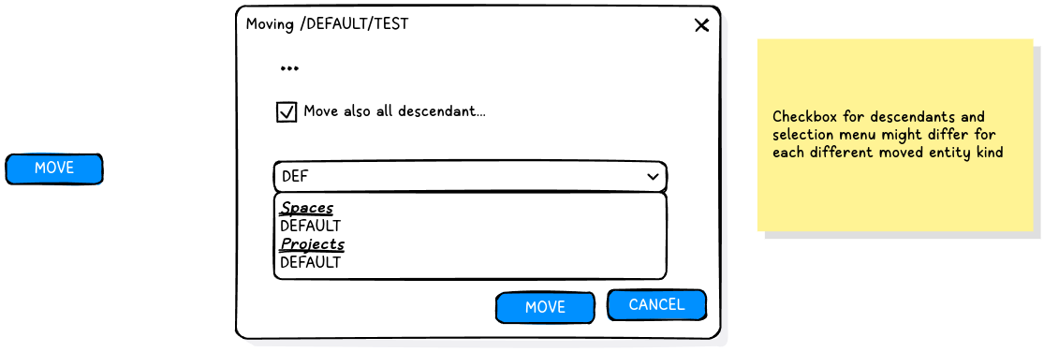
Project Delete
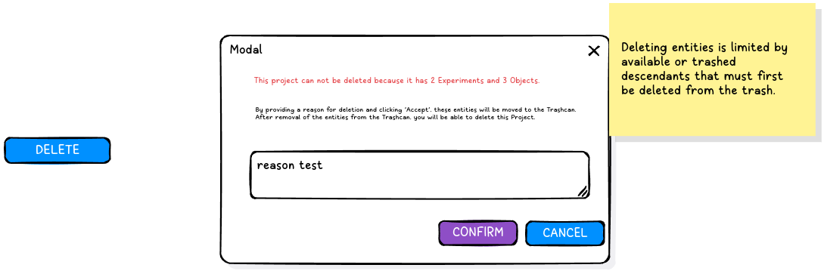

Model
Same as previous section

Requirements

Functional Requirements
MOVE
- Move Space: Spaces cannot be moved, don’t show the button
- Move Project: Projects can be moved between spaces.
- Move Collections: Collection can be moved between projects.
- Move Object: Objects can be moved between spaces, projects and collections.
- Move DataSets: DataSets can be moved between objects and collections.
DELETE
- Delete Space: Delete space immediately, the space needs to be empty. Show a warning if not empty.
- Delete Project:
  - If the project is empty: Delete project immediately, the project needs to be empty. Show a warning if not empty.
  - If the project is non empty: Allows to move all its entities to the trashcan.
- Delete Collection: Moves to trashcan the collection and all its objects and datasets.
- Delete Object: Moves to trashcan the object and all its datasets. Optionally, a checkbox to trash the descendants object and all its datasets can be selected.
- Delete Dataset: Moves to trashcan the dataset. Optionally, a checkbox to trash the descendants datasets.

4. Form Creations

Views
Same as previous section
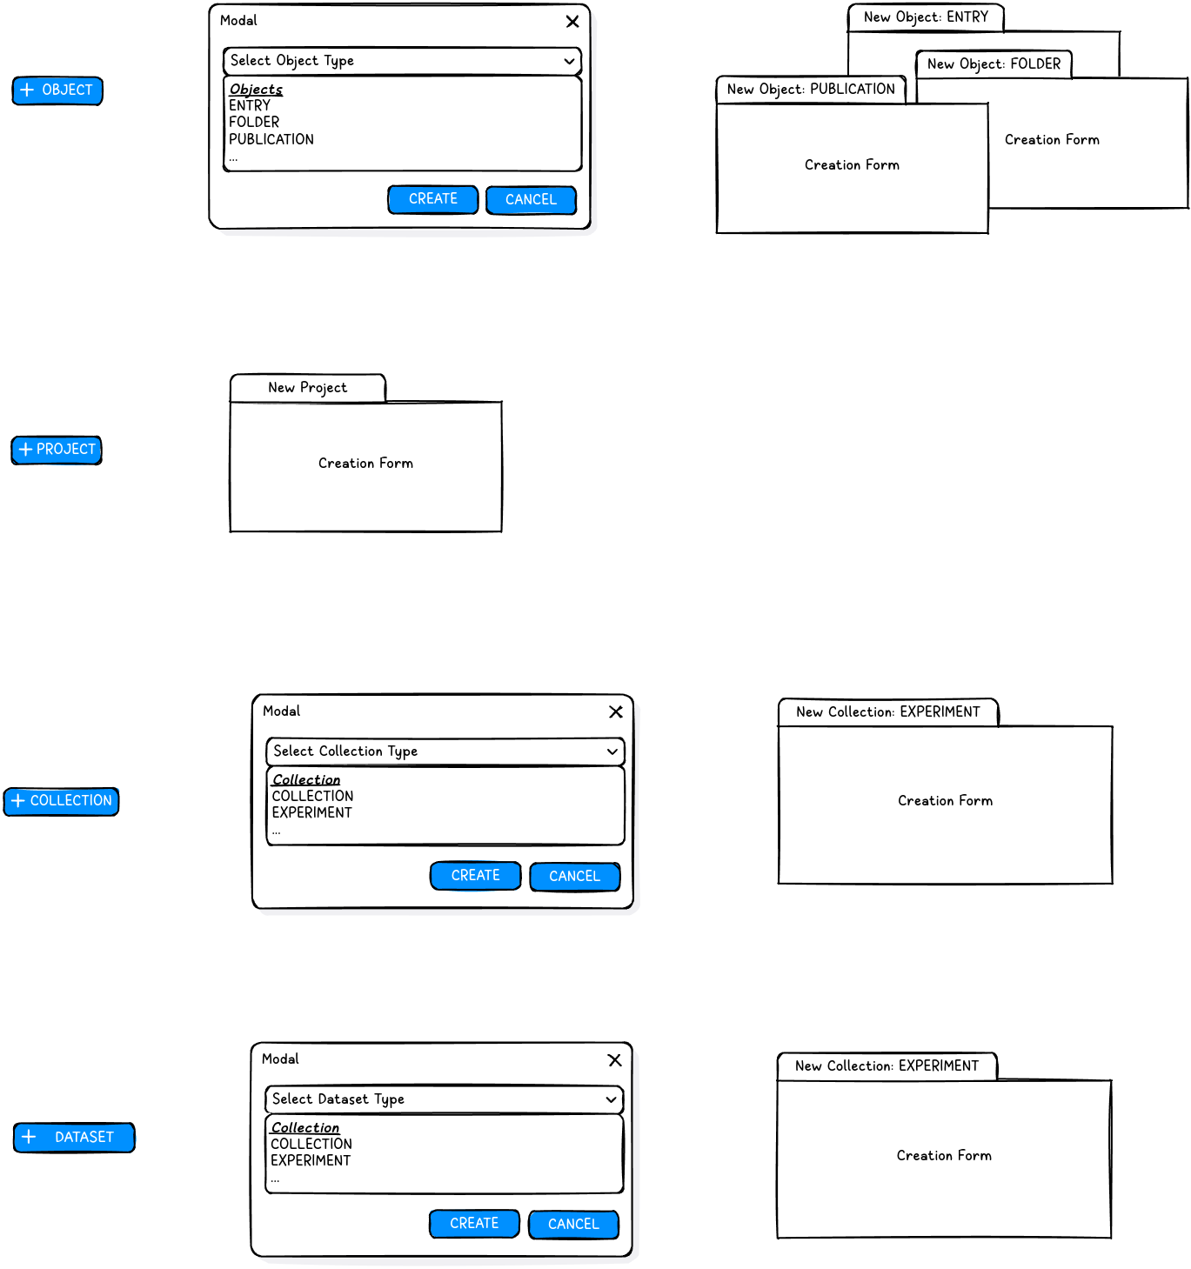

Model
Same as previous section

Requirements

Functional Requirements
- Create Space: Not to be done at this moment.
- Create Project:
  - Action Initiated from the Space Form.
- Create Collection:
  - Action initiated from the Project Form
  - A dropdown to select the Experiment Type is shown to select it.
- Create Object:
  - Action initiated from the Space Form, Project Form, Experiment Form, Object Form.
  - A dropdown to select the Sample Type is shown to select it.
- Create DataSet:
  - Action initiated from the Object Form and Experiment Form.
  - A dropdown to select the DataSet Type is shown to select it.

5. Form Visualization and Edit – Part 2 (Muti-Valued Fields)

Views
Same as previous section
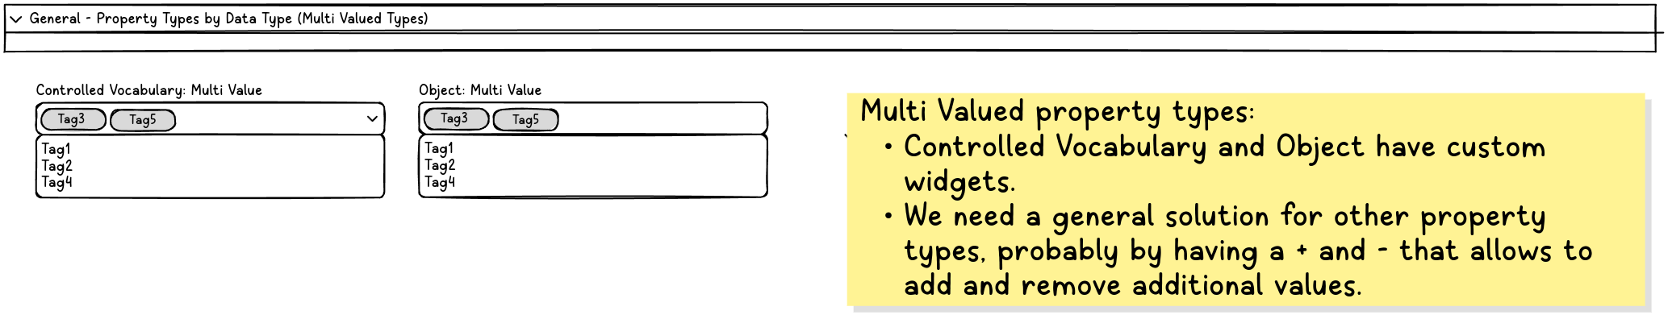Model
Same as previous section
On the V3 API, looking at AbstractEntityPropertyHolder.java we can see that:
Array properties are represented as arrays, ex: Long[]
Multi valued properties are represented as lists, ex: List<Long>
Multi valued array properties combine both, ex: List<Long[]>
Sample, Experiment and DataSet DTOs should implement AbstractEntityPropertyHolder that implements the serialization and deserialization of compound data types.
To read and write any properties but specially compound data types the get and set methods of the DTOs should be used. Even if luckily in Javascript arrays and lists are represented the same way.

Requirements

Functional Requirements
- Data Types (multi valued)
  - For known values:
    - Objects: Multi-select dropdown with as you type
    - Vocabulary Term: Multi-select dropdown with as you type
  - For open ended values:
    - Other: Show the single value field, with a plus and a minus to add and remove values.

6. Form Visualization and Edit – Part 3 (Spreadsheet)

Views
Same as previous section
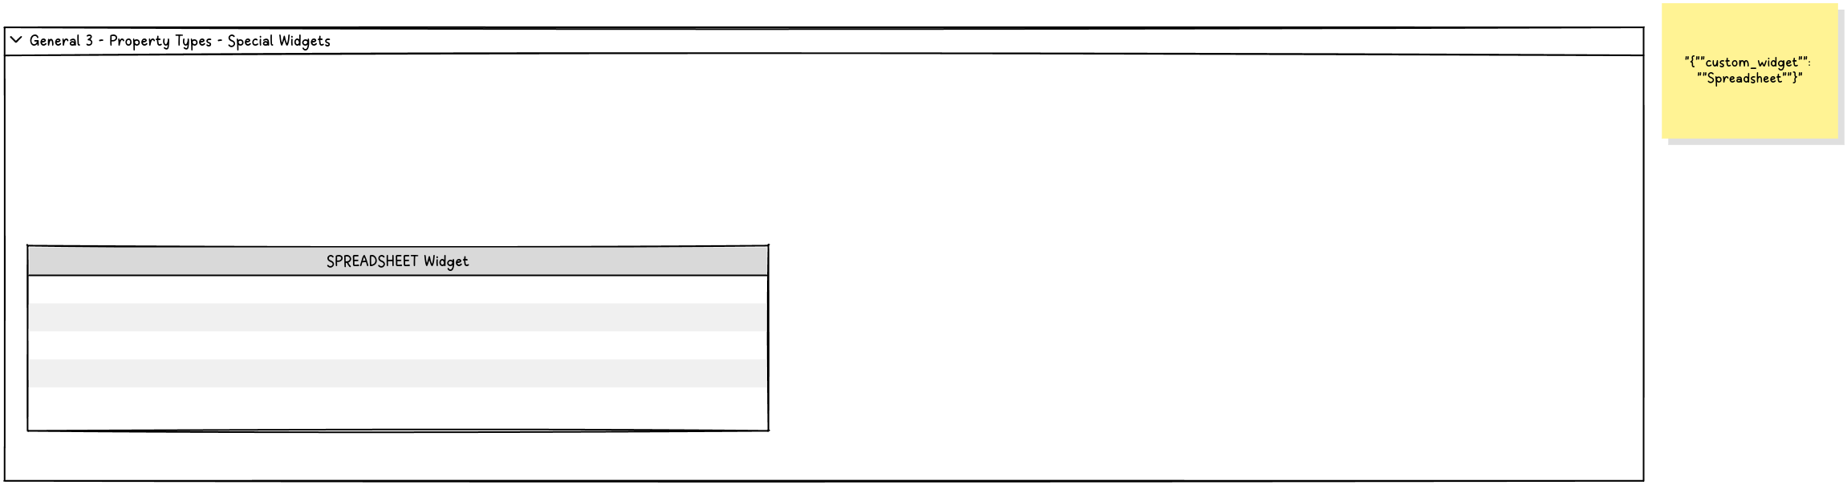

Model
Same as previous section
Data Type: XML
Metadata: { “custom_widget” : “Spreadsheet” }

Requirements

Functional Requirements
- Integrate spreadsheet component:
  - https://bossanova.uk/jspreadsheet/: jspreadsheet community edition with support for formulas.
  - It should be implemented reading and writing the same model as used by the ELN on the properties. There is a Spreadsheet DTO.

7. Advanced Toolbar Actions

Views
Same as previous section
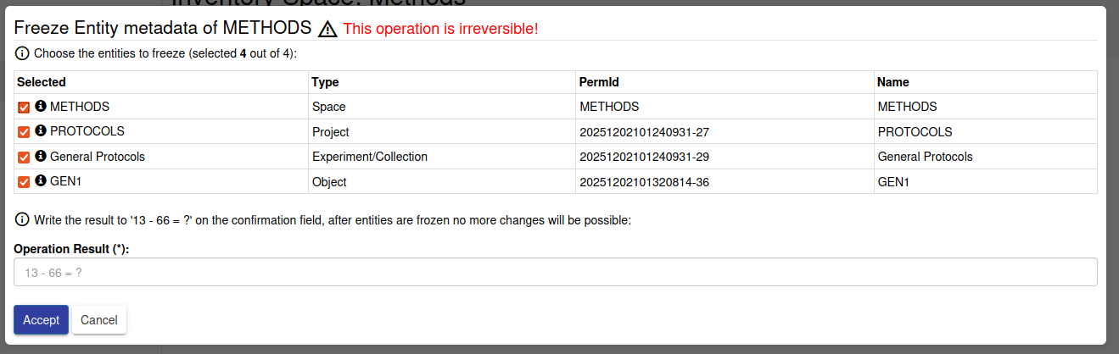
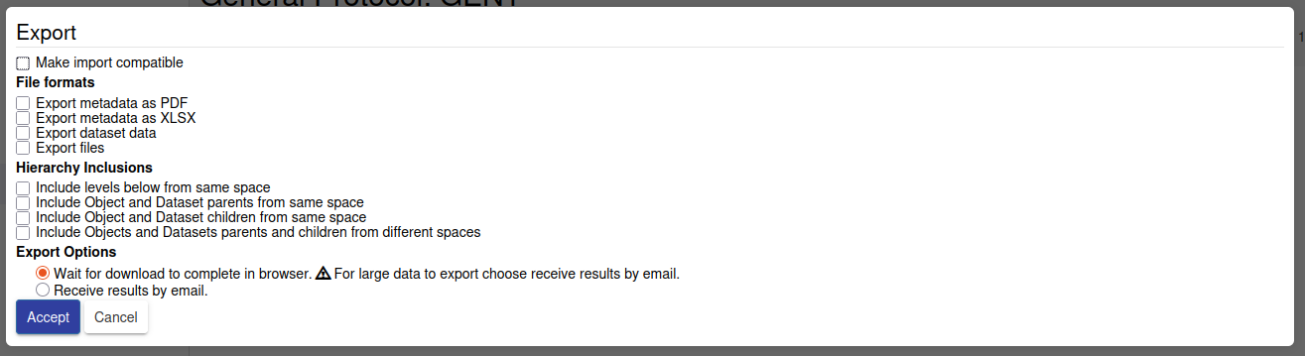

Model
Same as previous section

Requirements

Functional Requirements
- Freeze
  - During a freeze metadata operation the downstream entities of the selected entity are shown, and the user is given the opportunity to make them part of the freeze operation.
  - Collections and Objects do have a second operation, “freeze data”, same behavior as the previous one but setting the other flag.
  - During the freeze operation, an update is sent to the SELECTED entities, marking their freeze or freeze data flag to TRUE.
  - If an entity is frozen, it cannot be edited.
- Freeze Flags to be used, when freeze an entity for metadata:
  - Space: frozen, frozenForProjects, frozenForSamples
  - Project: frozen, frozenForExperiments, frozenForSamples
  - Experiment: frozen, frozenForSamples
  - Sample: frozen, frozenForComponents
  - DataSet: frozen, frozenForComponents, frozenForContainers
- Freeze Flags to be used, when freeze an entity for data:
  - Experiment: frozenForDataSest
  - Sample: frozenForDataSets
- Space/Project/Collection/Object/DataSet Export:
  - They can reuse the same pop component, but when calling the export API, they are calling it, using their ID.

8. Form Visualization and Edit – Part 4 (Parents/Child widget)

Views
Same as previous section

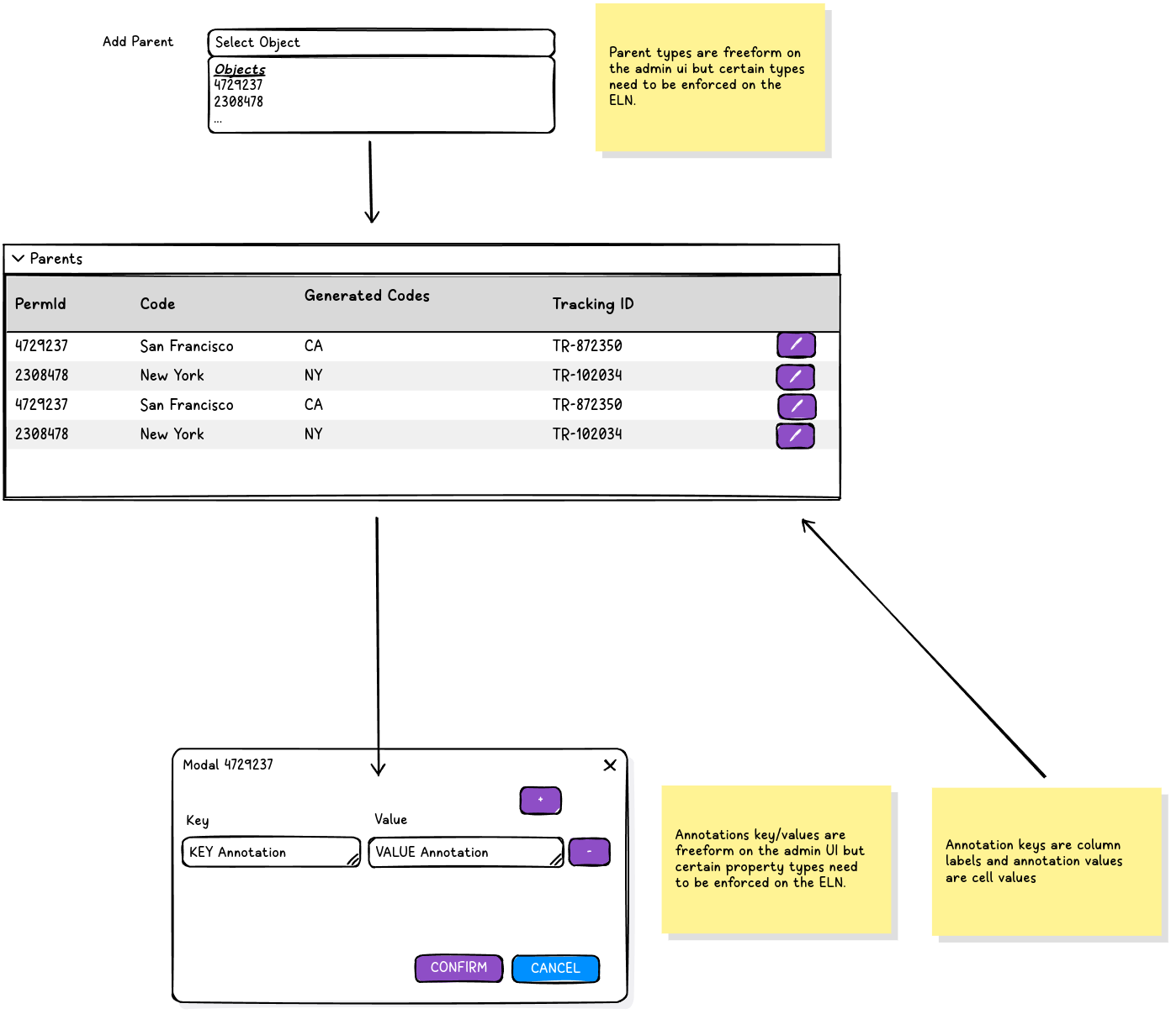

Model
Same as previous section

Requirements
Same as previous section

9. Plugin System (To be used by ELN to integrate Storage and other)

View
Same as previous section

Model
Same as previous section

Requirements

Functional Requirements
- This part should be tackle prior to the ELN integration.
- Should be possible to specify additional components in certain parts of the form, at the very least at the top and bottom but a more polyvalent interface can be suggested. The end goal is to be able to plug the plugin components given by the ELN plugin interface on the form. Even if needs to be accepted that such plugins may need to be adapted to work properly with the new Forms.

